**Assignment 8.1**

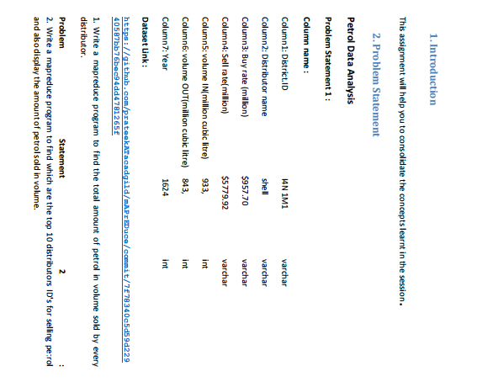

1. **Write a mapreduce program to find the total amount of petrol in volume sold by every distributor.**

**DRIVER CLASS**

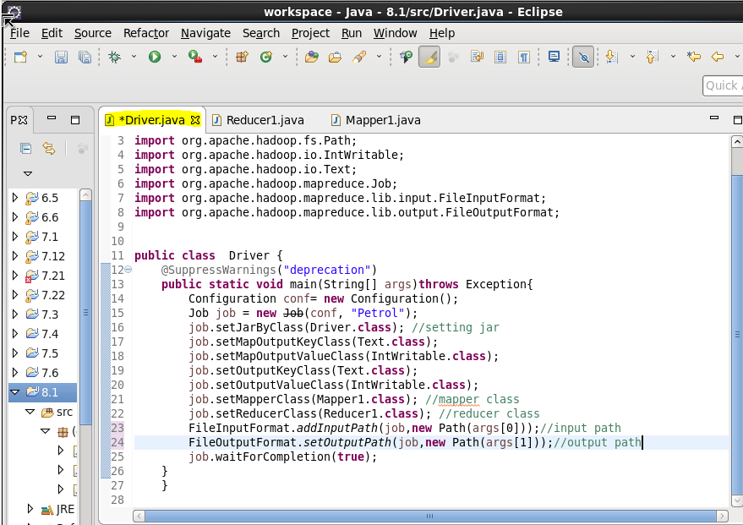

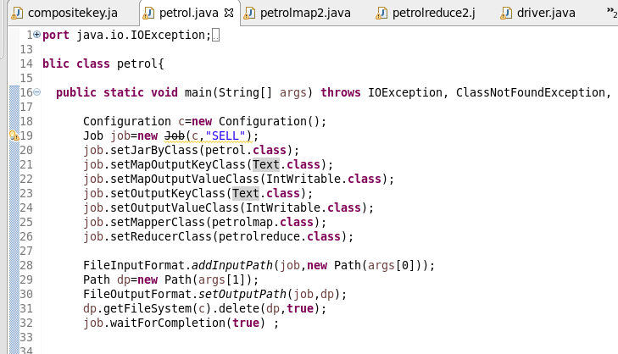

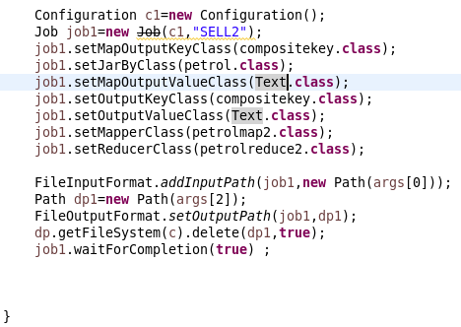

**MAPPER**

**SPLIITING THE DATASET BY COMMA AND SENDING DISTRIBUTOR NAME AS KEY AND VALUE AS SOLD VOLUME**

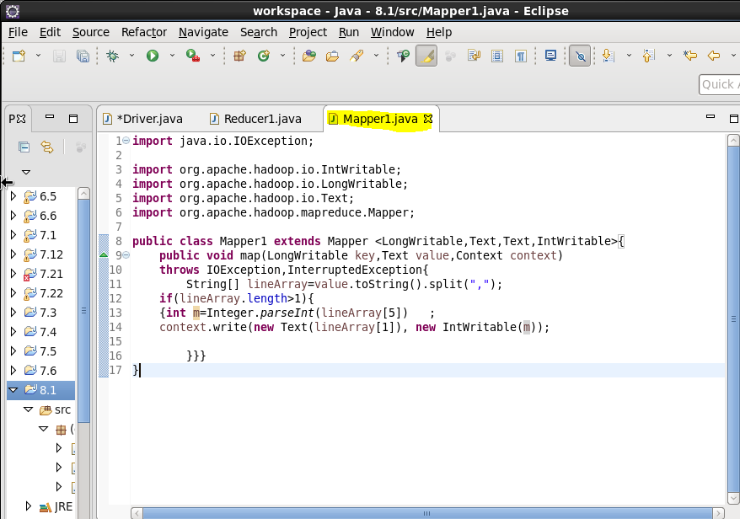

**REDUCER**

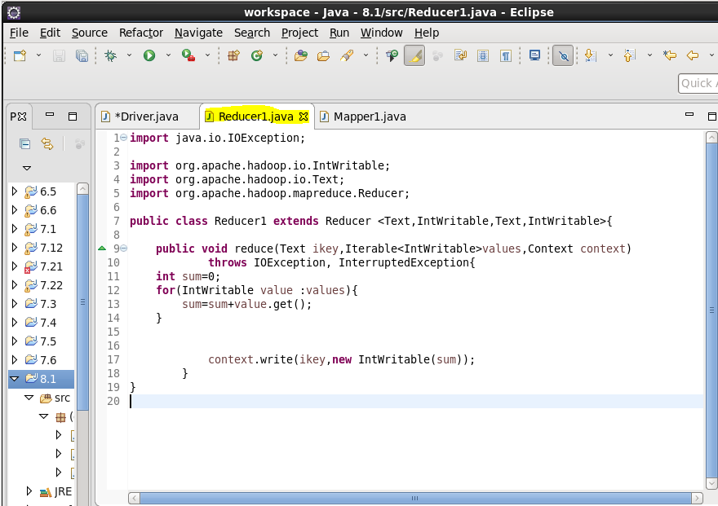

**OUTPUT**

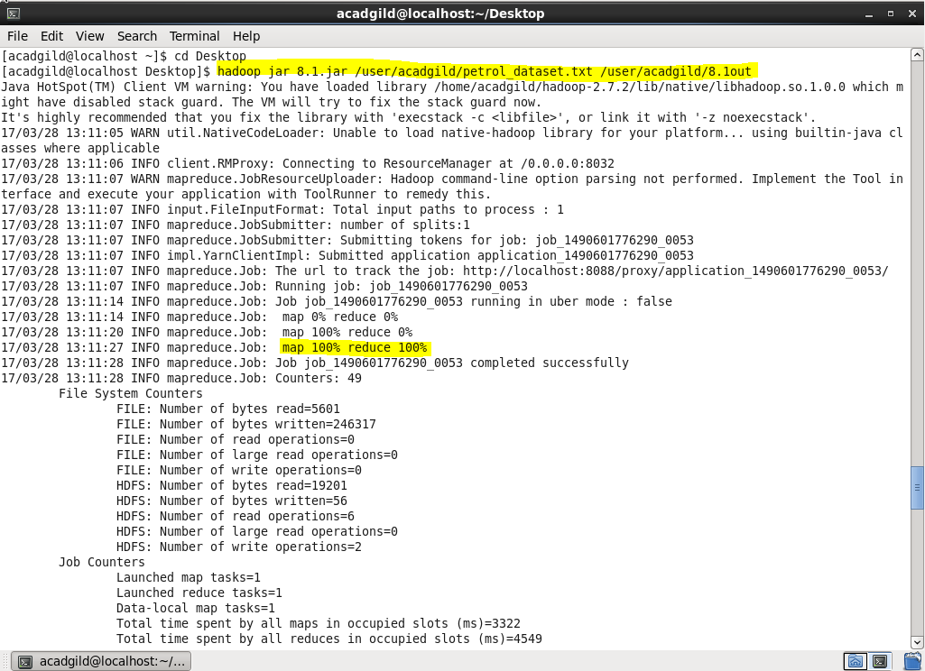

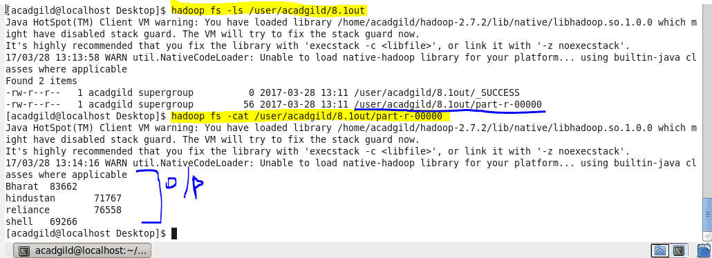

1. **Write a mapreduce program to find which are the top 10 distributors ID's for selling petrol and also display the amount of petrol sold in volume.**

**DRIVER**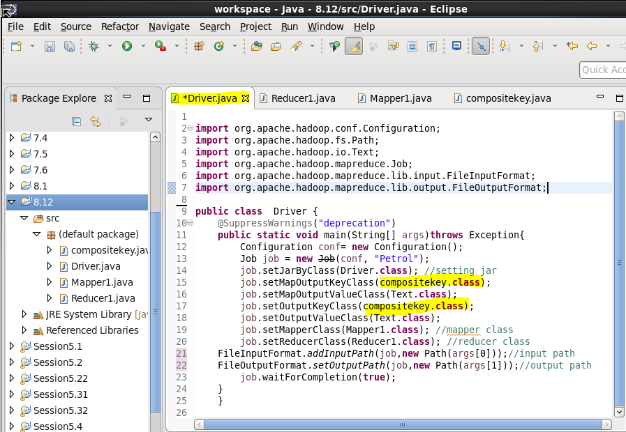

**MAPPER**

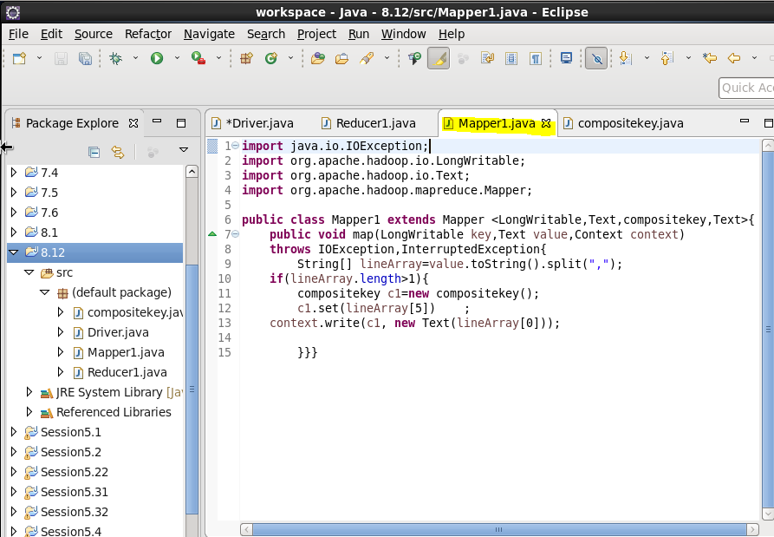

**REDUCER1**

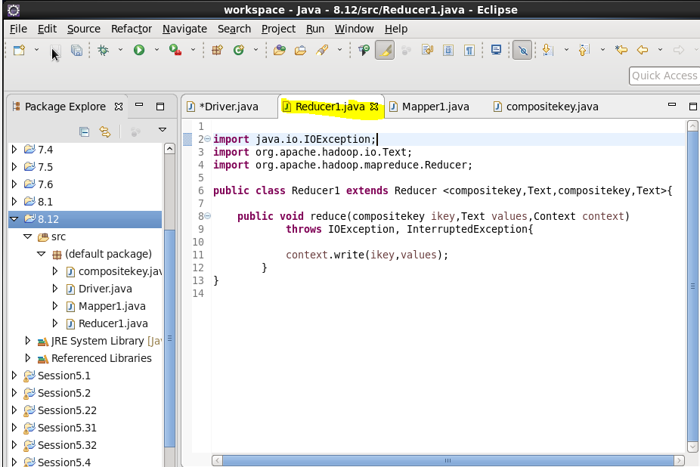

**COMPOSITE KEY**

*OVERRIDE COMPARE TO METHOD AND MULTIPLIED THE OTPT OF COMPARE TO BY -1 SO THE KEY WHICH WILL BE SORTED IN DESCENDING ORDER AND VOLUME SOLD AS VALUE*

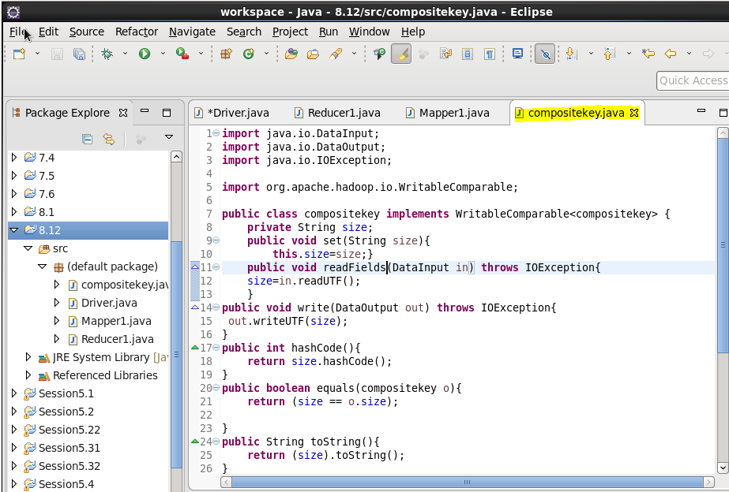

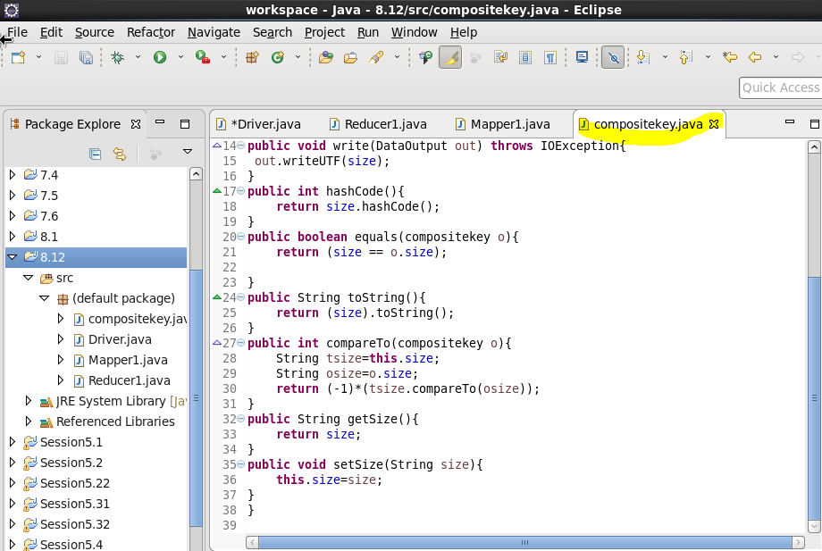

**RUNNING JAR**

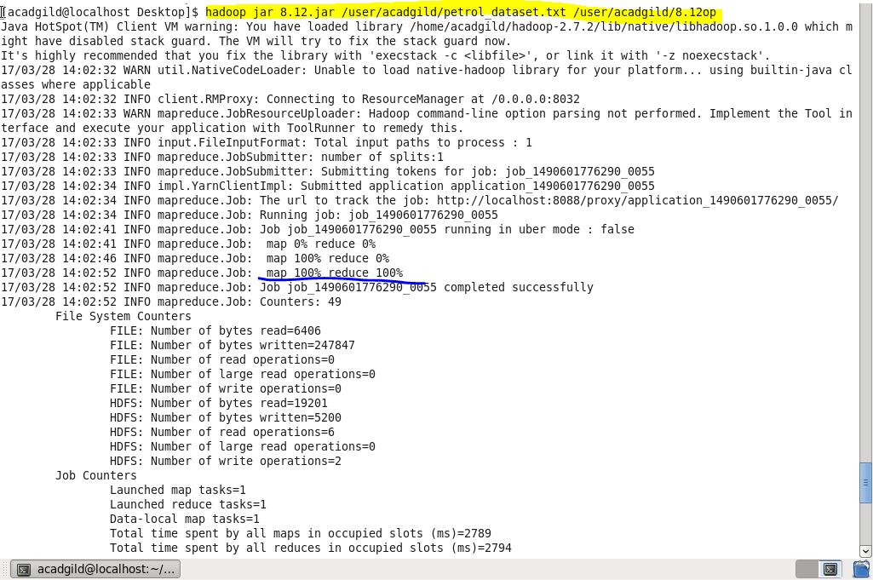

**OUTPUT**

TO GET TOP 10 VALUE WE CAN USE

HEAD –N10 COMMAND

